ESC project
Youth Work 2.0
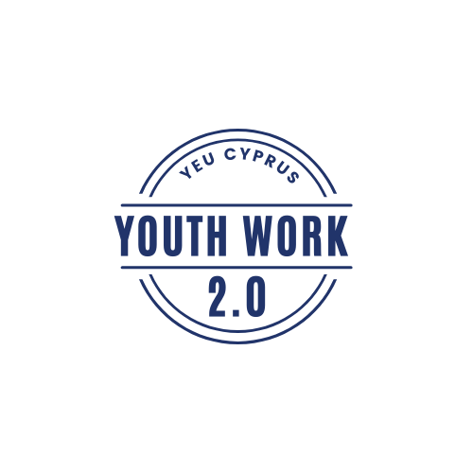

-
YEU Cyprus
2021 – 2022
Introduction
Dear future ESC Volunteers, we are happy to welcome you to this project! Please read the following information carefully in order to prepare for the coming time in Cyprus. Seven volunteers from seven different countries will come to Cyprus and share their experiences, skills and knowledge. You will have the opportunity to exchange your thoughts, experiences, visions, wishes and knowledge and have an unforgettable experience in Cyprus.
Furthermore, through this project you will have the opportunity to enhance the 8 Key Competences for lifelong learning. But let’s take the things from the beginning...

YEU Cyprus
YEU Cyprus stands for Youth for Exchange and Understanding Cyprus and it is a nonpolitical, non-governmental organization (NGO) based in Nicosia, Cyprus. Since 1995, the aim of YEU is to foster closer co-operation and better understanding among youngsters through the exchange of experiences and ideas. It is one of the biggest youth organizations in Cyprus numbering more than 1000 members and is considered one of the most active organizations of the island, realizing several activities both on an international and local level.

YEU Cyprus activities:
- On an international level, we organize and deliver training courses, focusing always on the youth’s development, awareness raising and capacity building. The methodology of the activities is based on non- formal education and experiential learning.
- Providing the opportunity to participate in international activities abroad such as in partner’s training courses, youth exchanges, European Solidarity Corps (ESC), seminars, SALTO events etc.
- On a local level, YEU Cyprus has organized and still organizes various activities such as Human Libraries, workshops and seminars on different topics (for example human trafficking, non-formal education, volunteering), street festivals, laughter festival, field trips and other activities.
For more information have a look at our Facebook page and our website.

YEU Cyprus Contact Information
Phone number
YEU: 00357 99573646
E-mail address:
evs@yeu-cyprus.org
info@yeucyprus.org
Address of YEU:
27 Ezekia Papaioannou, 1075 Nicosia
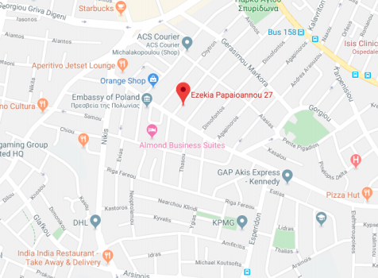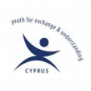

What is Youth Work 2.0 about?
In short, “Youth work 2.0” aims to improve the processes and competencies of youth workers for them to provide quality opportunities and effective support to young people. It aims to reach this ultimate goal via improving its online existence and expanding its service zone by doing the activities via the use of the internet.Creating and improving the online existence for the youth, youth workers and other stakeholders in order to implement, share and raise awareness of the EU youth strategy (Engage,Connect and Empower) via online NFE methods.
A few objectives were in our minds while designing the project:
- To foster and develop increased opportunities for young people, by supporting them in creating grassroot initiatives and youth-led projects.
- Empower marginalized youth and underrepresented youth and improve their capacities to become informed decision makers and change makers in their communities.
- To explore and develop NFE methods and techniques and actively use these techniques on the topics of youth. Enhance cross-sector innovation and collaboration with young people
- To create networks and coalitions among youth organizations, young people across the EU and non-EU.
- To create an environment that would favour the development of future Non-Formal Learning projects and cooperation in the education and volunteering field across Europe.
- Improve the capacities of youth workers through the creation of capacity building processes.
- Equip youth workers with the competencies (knowledge, skills and attitudes) in the use of digital technology.
- To carry out a set of pilot sessions/workshops on youth work and relevant topics (e.g. intercultural communication, sustainability training etc.) with a number of youth organization representatives (e.g. youth workers, teachers, students, parents, policy makers, adults returning to higher education, learners entering the workplace) in order to enrich/ localize/ adapt content to current needs and evaluate the proposed approach.
Activities
During the volunteering, 5 main activities have been drafted for the volunteer in order to achieve the goals and give a direction to the project:
- Create a Social Media Marketing Strategy that is a good fit for YEU Cyprus and its online existence mainly based on the European Youth Strategy of the EU Youth Policy and contents are oversimplified, catchy and informative.
- Create web-content on a weekly basis and a youth-friendly website. Web-content will be done through the use of specific templates and software. It will be published across YEU Cyprus social media accounts. Posts will be decided based on EU trend topics/information and others on YEU Cyprus events and activities.
- Create audiovisual material. A series of YouTube videos will be created through a call of volunteers. The Videos will be mainly about Non formal Education and experiential activities that can go viral. The main aim of the videos will be creating catchy videos that can attract people and make them discover more about Youth Work and YEU Cyprus.
- Create policies for the organization or other youth NGO’s. Through a focus group which we will initiate we will ask which internal policies are more essential for Cypriot NGO’s and with the help of experts create them.
- Create manuals for a series of workshops e.g. Promotion of EU opportunities for young people, Intercultural communication etc. that can be implemented offline and online.
Volunteer’s profile.
• Competencies and motivation to work with people coming from different backgrounds, willing to learn new things and eager to learn about different cultures.
• Preferably be over 20 years old, open-minded towards multiple working methods, different languages, mentalities and be interested to create new experiences in an inter-cultural environment.
• They should also show that they are able to support themselves financially throughout the period that the project is being carried out with the financial means provided by the organisation.
• We do not require any qualifications like educational achievements or knowledge upon specific experiences. We only require basic English-speaking language knowledge.
• Ideally we are looking for volunteers who have a passion about Youth work and are familiar with the European Youth Goals.
Volunteers will be chosen regardless of their ethnic group, religion, sexual orientation or political opinion.
Country
We will have one volunteer coming from one of the following countries: Turkey, Hungary, Slovakia, Greece, Croatia, Bulgaria, Romania.

Benefits of being part of an ESC
Skill development
• Empowering self-management and work-related skills (time management, planning, priorities, responsibility, ability to complete a project).
• Strengthen existing skills through practice and experience such as argumentation, influence and negotiation.
• Reflection of interpersonal skills through work and communication with others.
• Cultivating team spirit and teamwork and synergy skills. • Constant interest in acquiring new skills.
• Strengthen communication skills, spoken and written, by writing reports, citations, abstracts, posters, articles.
• Cultivating team spirit and teamwork and synergy skills
Working experience
• Experience in decision making and problem solving.
• Participation in a variety of learning experiences and normal work environments.
• Experience of working with a team and with third parties at varying levels.
• Leadership development opportunities.
• Opportunity to demonstrate their capabilities.
• Acquire specialization and experience to enrich their personal curriculum and improve their future professional choices.
• Increased ability to learn from experience.
• Encourage initiatives and free creativity.
• Improving independence.
• Enriching cultural knowledge.
• Youth Pass.

YEU Volunteers testimonies.
Oscar’s:
Everything in new, huge experiences like the volunteer projects move so fast. In the past four months I’ve been a photographer, trainer, chef, event manager, writer, researcher, interviewer, project writer, waiter, cameraman, teacher, mediator, coacher, marketer and many other things that I can’t remember right now. Many of the fears of the beginning don’t disappear but to realize that I’ve made so many different things it’s a big shot of self-confidence. New skills are growing in me and the old
ones have been reinforced. Mission Tradition is being, in just a word, amazing.
Alessia’s:
It’s not easy to summarize all that I’ve learned and I am still learning thanks to this experience, because every day is an occasion not only to learn, discover and improve my personal skills and qualities but also to understand what are my limits and what I can do to improve myself as person. I’ve worked as volunteer in several local festivals; travelled along the Island to discover it’s amazing tradition and delicious foods; I’ve learned how to plan, create and promote events and workshops; some days I’ve been a cook and a kitchen helper, others a teacher of Italian language. I suggest that everyone tries an EVS experience. Personally I believe that working in a multicultural context and interacting with people from different cultures it’s a unique and challenging possibility not only to understand and appreciate different realities and life styles, but is also an occasion to “get in the game”, leaving your comfort zone and taking your time to reflect more on yourself and what you really want to became.
Gabriele’s
For my main interests, in Italy I was unemployed, so I decided to take the last train I could to make an experience like that: the age limit for a ESC is 30 years old and, having this age, I chose to spent one year abroad living an amazing experience! Fortunately, I did not found difficulties to get used to the local lifestyle, I adapt myself very easily and the “σιγά, σιγά” (sigà sigà - slowly slowly) culture here fits very well in my lifestyle! Volunteering abroad is a great occasion to meet new people, have a great time thanks to European mobility programs. Knowing different cultures, deal with a new uses and new way of life, cooperate with people from all Europe and know people from all the word is a great occasion to verify how much a person is open minded and grow up as an individual. Is a great occasion that I suggest to experience and
every young person can apply.
Michaela’s:
If you are thinking about doing ESC, you should be aware that of course the experience depends on the project’s objectives and the personalities you are going to meet and work with. But I definitely suggest that you
try it. It gave me confidence which is so much needed in life, and I have a great time here in general. Usually we have a lot of fun in our office; so far, I volunteered in several arts festivals, travelled around the island, enjoyed the delicious food and local hospitality, which by the way is limitless. Volunteering can teach you that money is not the only value one can gain, acquiring experiences it is invaluable. You will gain so many new skills or discover the ones that were already there but never knew about them. Above all, when you are doing something meaningful, “a good deed”, it will enrich your heart… Improve your improvising skills, come to Cyprus!
Period of the Project
As soon as possible for a duration of one year.
Working hours
ESC must be full-time service for the volunteer. Her/his project activities (including language and other training activities relating to the project) should take up at least 30 and not more than 38 hours per week (around 7 hours per day). If they will work more than 35 hour per week, they will recover the hours in the same month. In case of working on the weekend for a day, they have the right to take a day off in the same month. The volunteer is entitled to two consecutive free days per week (weekend) and two days of holiday per month.
Language support
All volunteers will be provided with a language support: there will be one Greek lesson every week for 2 hours. Furthermore, the volunteers will be enrolled in the OLS (online linguistic support) platform to have extra material to work with to enhance their Greek language learning. We recommend that all volunteers take advantage of this opportunity because it will help establish a better communication with the locals.
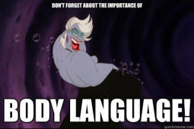
Finances
Every volunteer will receive 140 Euros for food allowance and 5 Euros a day for pocket money. The accommodation will be provided by YEU Cyprus. The volunteers are requested to be very careful on electricity and water bills. A maximum allowance of 75 Euros will be provided for Electricity and Water bills per month for each house. In case that amount is exceeded, the volunteers will be requested to provide the extra costs.

Health insurance
Sending organization is responsible to register the volunteers to the CIGNA INSURANCE at least 14 days before departure. Volunteers will also receive from the sending organization information about the coverage and the procedure of CIGNA INSURANCE. Volunteers are strongly advised to have the European Insurance card with them given by their national provider.
About the Project

We are facing a global crisis unlike any other that will have a huge impact, especially on young people’s lives. Even though it is still very challenging to estimate exactly the impact of COVID-19 on young people, there is a global call for action to mitigate the socio-economic impact and accelerate recovery (UNDESA policy brief n67). Based on Eurobarometer 455 & 478, young people have voiced a priority to fight climate change, improve education and training and fight poverty and social inequalities. Topics that are not sufficiently targeted are critical thinking, the environment, entrepreneurship, climate change and only 1/3 of young people in Europe have the opportunity to talk directly to policy- makers to create the change towards the challenges they face.
Moreover, Young people are amongst those impacted by the current crisis in terms of mental and physical health, learning and professional development, civic engagement and respect for their rights – on all these fronts young people are also facing important disruptions and changes. One of the most disruptive results is youth unemployment, the global youth unemployment rate is three times higher than for adults (OECD, 2018 data) and it is expected to increase sharply. The other one is mental health and wellbeing. A young person who has to face these difficulties is in most cases a fragile person and needs support for his/her life journey.

Via this project, youth who are having difficulties because of the unemployment will be supported. There is also an understanding that there are needs of young people that have not been responded to, leaving many to face on their own issues related to social exclusion, discrimination and a redefinition of social and safety nets. There are also questions about changing relationships and behaviour, changing perspectives on connection to friends and community, impact on well-being and mental health, employment, participation, activism, youth organisations and many other areas of young people’s lives. The way of supporting will be about providing opportunities one can improve himself or herself, Reaching out to vulnerable groups, such as minorities and young people with disabilities, providing them with guidance, information and mentoring.

The other societal needs that we will be seeking to address is the sustainability of the work of youth workers. The youth sector is significantly affected by covid-19. While there is a clear emergence of digital youth work and increasing use of digital tools in working with young people within both formal and non-formal education across Europe so via this project , it has been aimed to be a part of this change.

Accommodation
The accommodation will be provided by YEU Cyprus at a house in the city of Nicosia, keeping in mind the needs of the volunteer and good accessibility to the office and the services the volunteer might need.

Travelling to Cyprus and Transportation
In Cyprus there are two airports: Larnaca and Paphos International Airport. The Ercan Airport located at the northern part of the island is not recognized by any other country except Turkey therefore if your inbound and outbound flight is to and from Ercan Airport, you will not be able to get your money reimbursed. Moreover the checkpoints are currently closed hence access from Ercan Airport is restricted.
Kapnos Airport Shuttle located in Kyrineías street, is the best way to get to and from any of the 2 Airports. The ticket to Larnaca Airport is 8 Euro while the ticket to Paphos Airport is 15 Euro.
Buses are the most affordable way to travel within the city or to go from one city to the other
Check the following websites for more information:
1.http://www.cyprusbybus.com/
2. http://www.intercity-buses.com/
The Application Moovit, it’s a good way to have access to busses timetables.
YEU Cyprus team will provide all volunteers with bicycles which they can use in their daily life. Remember to lock your bicycles when you are around and bring them inside the house when you are at home!

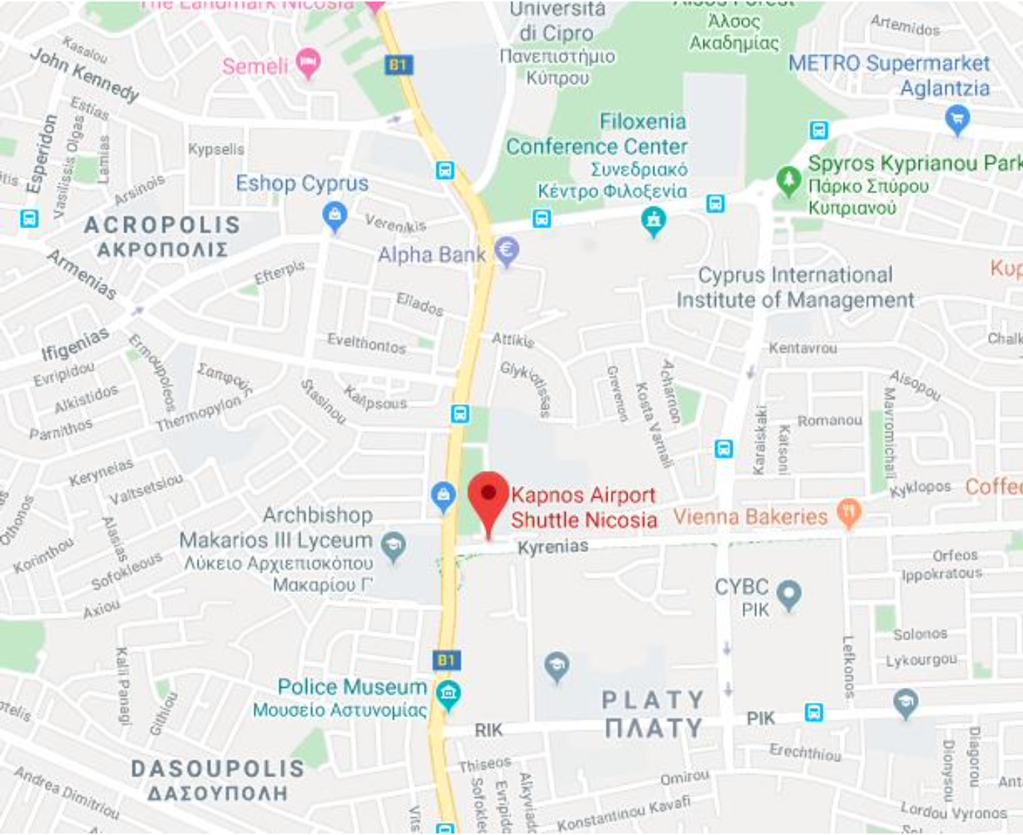

Travel allowance
The volunteer has the right to an allowance for the travel expenses (return flight) based on the ESC guide on the kilometers distance reference. Specifically from Turkey the amount is 275€.
Money and Currency
The currency of the Republic of Cyprus is the Euro.
Making Phone Calls
In order to make a phone call to Cyprus from abroad, dial 00357 or +357 and then the eight-digit phone number. If you wish to make a phone call abroad while in Cyprus, dial 00 or +, followed by the country code and the telephone number. The organization will not provide SIM cards. Each volunteer can choose if they want to buy their own Cypriot SIM card.
Languages
Greek and Turkish are the official languages of the Republic of Cyprus spoken by the Greek-Cypriot and Turkish-Cypriot communities respectively. English is widely spoken. Russian, French, German and other languages are also well spoken within the tourist industry.
Religions
Cyprus enjoys an exceedingly high level of freedom of worship. While the majority of Greek-Cypriots are Greek-Orthodox Christians, there are also other denominations represented on the island including Armenians, Maronites and Roman Catholics. The Turkish-Cypriot community is predominantly Muslim.
Weather Conditions
Cyprus enjoys an intense Mediterranean climate of very hot and dry summers starting in mid-May and lasting until mid-September. Winters are usually quite mild and last from November to mid March. September to November and March to May are the months when the season changes to Autumn and Spring accordingly. The summer months are very hot so you will need comfortable and light clothing. Don’t forget to bring your swimming suit and go explore the beautiful coastline of the island where you will find clear
eaters to swim in. What’s more, is that light long sleeves and jumpers are necessary for the evenings at the beginning and end of the summer.

During winter you will need warm cloths and a warm waterproof coat as it gets very cold sometimes. Temperatures are usually above zero unless you go to the mountains at night. Flipflops and sneakers are the 2 footwear you will definitely need. If you have warm waterproof boots to bring along for winter that will also come in handy. There is snow on Troodos mountain in winter and there you have the opportunity to go skiing down our small slopes.
Events
Throughout the year there are many events happening on the island. For instance, in the summer there are multiple music festivals like Fengaros, The Afro Banana Republic, Loud Music Festival and many more. There are food festivals like Fork Market which happens throughout the year in Nicosia and offers a variety of cuisines
and it is also vegetarian and vegan friendly.
There are multiple workshops happening every week and you can look for them on Facebook, Airbnb Experience and websites like Wiz Guide, In-Cyprus to which we have attached the links below.
https://cyprus.wiz-guide.com/
https://in-cyprus.com/
Most of the movies playing at the cinema are in English with Greek subtitles. Sometimes there are also Russian, Greek and French movies playing. There are 2 main cinema theaters in Nicosia, K Cineplex and RIO Premier Cinema.
https://www.kcineplex.com/
http://www.riocinemas.com.cy/
Cyprus and Nicosia offer many things to do as long as you know how to properly search for them.

What to Bring
• Comfortable clothing (Cyprus is well known for its really hot weather but it can also get quite cold in winter).
• Medication, if needed.
• Laptop (in case it is difficult to bring one, please inform us in advance).
• Alarm clock (to avoid oversleeping).
• Swimming suite…!
• Motivation and good mood!
Cyprus
A beautiful island in Eastern Mediterranean Sea very close to Turkey, Syria, Lebanon, Israel, Jordan and Egypt. The cultural diversity in Cyprus is vast and within Nicosia it is predominantly seen within the old walled city. It is a kaleidoscopic blend: its cultural influences are dominated by Western Europe, but its geographic proximity to Asia and Africa gives it more than just a hint of the East. Long coveted by Greece and Turkey, this small island has its own captivating culture. Cyprus is the island of
all seasons, the island of good weather, good mood and loads of sunshine! The people of Cyprus are warmhearted, hospitable and kind, there are people who love going out and who appreciate good company. The capital city Nicosia is a city which blends both history and modern life while at the same time it is also the last divided capital city in the World. The northern part of the city functions as the capital of the Turkish Republic of Northern Cyprus, a disputed region recognized only by Turkey and which the international community recognizes as Cypriot territory under Turkish occupation and has done so since the Turkish invasion in 1974.
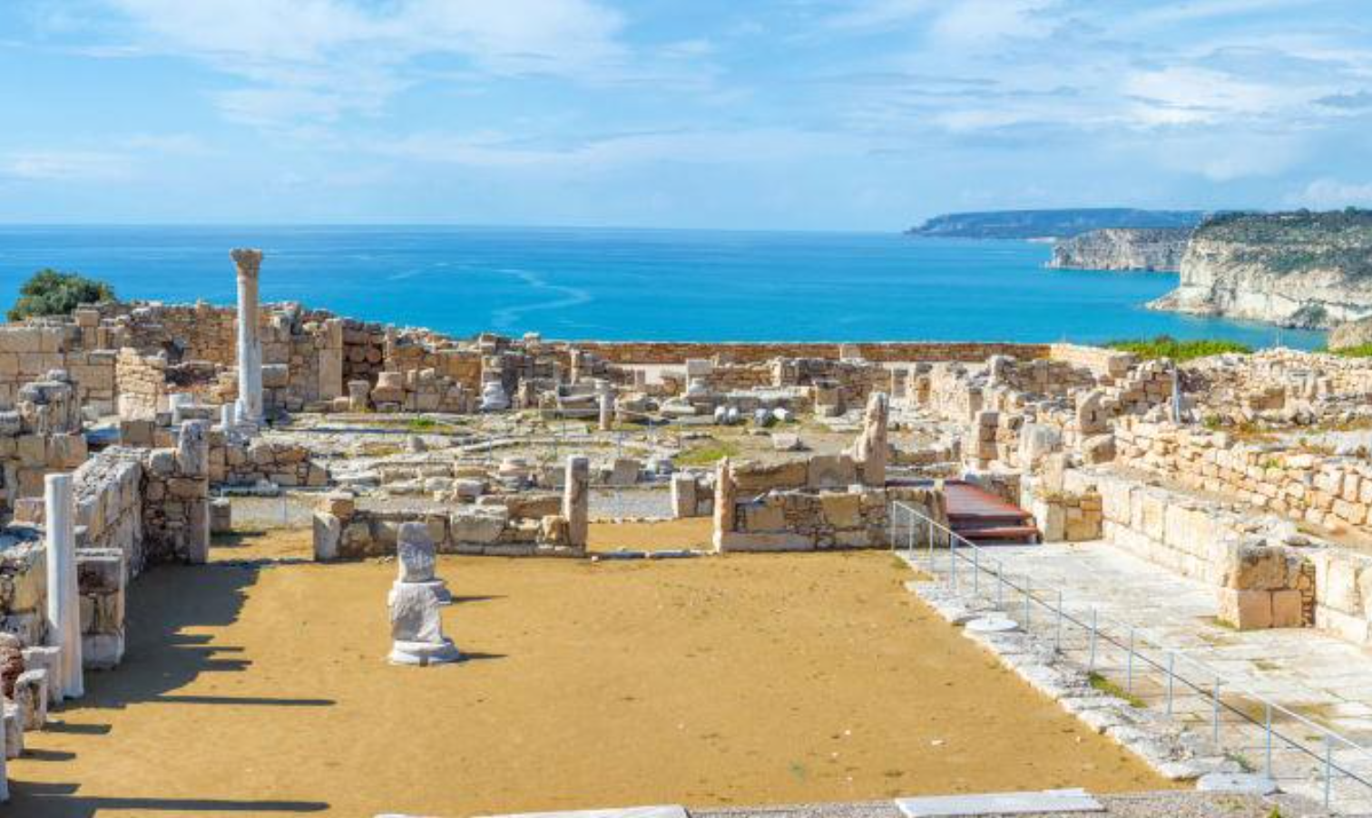
Nicosia
Nicosia is the capital city of the island. The old part of the city is surrounded by walls that were built by the Venetians in the mid-16th century (1567). As previously mentioned, the city is the last divided capital in the world. Within the walled city there is a checkpoint where people can show their passport or ID to cross to the Northern Part or vice versa. There are 2 other checkpoints outside the walled city and many more spread around the island. Nicosia is the cultural core of the island with much of the history and ethos of the country being preserved in museums, architecture and the way of living/ working. What is more, is the culture and customs brought in from people who migrated in Cyprus from various countries. A lot of expats live permanently in Nicosia, therefore don’t be surprised when you walk around and hear people speaking in languages like English, Russian, Turkish, Arabic, Romanian, Bulgarian and many more. This beautiful blend of people has added a very special touch to the culture of the city and you can start noticing that from the various restaurants around. The Middle Eastern food culture is one of the most vivid ones you will come across with many falafel shops and restaurants.
Going out at night in Nicosia you’ll notice that predominantly people drink beer and wine with cocktails coming in last. Zivania is the Cypriot version of vodka and it is something you should definitely try. The Cypriot way of drinking Zivania is in winter, in front of the fireplace while grilling some halloumi and sausages. Zivania should be drunk chilled straight from the freezer in shot glasses.

Historical Facts of The Island
During Ancient history different civilizations lived on the island, such as: Mycenaeans and Ancient Greeks, Hittites, Phoenicians, Assyrians, Egyptians, Persians, Macedonians, Ptolemais and Romans.
Middle Age: Byzantines, Arabs, Richard the Lionheart, Knights Templar and Lusignan.
Renaissance and Modern Era: Genoveses, Venetians and Ottomans.
Contemporary History: British.
In 1960, the Republic of Cyprus was formed.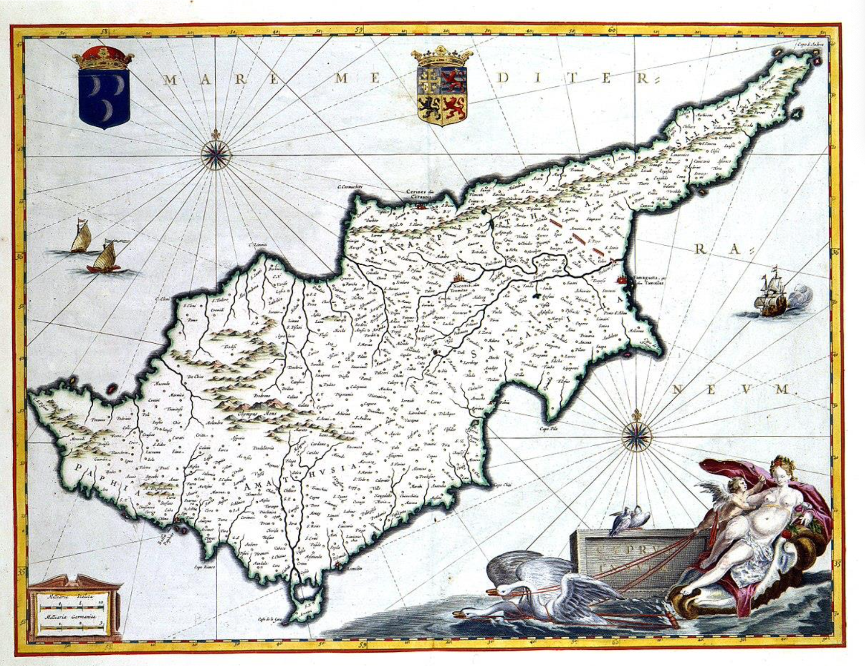

Cypriot Cuisine
People in Cyprus appreciate good food. In fact, most of the social outings and relationships revolve around food! And that food is coming in a diverse variety and large quantities for massive stomachs!
While in Cyprus it’s a must that you try:
• Cypriot meze (appetizers akin to Spanish tapas) are an art form. Meze is available in a meat or fish version but you can also find a combination, depending on the restaurant you are at.
• Sheftalia which is a kind of sausage without skin. The filling of Sheftalia is made of ground pork or lamb shoulder and leg. It is mixed with chopped onions and parsley and seasoned with salt and pepper. Instead of sausage casing it uses caulk fat, the membrane that covers the stomach of a lamb or pig, to wrap the ingredients. In words it may not sound so good but in the mouth,
it is simply yummy yummy!!!
• Halloumi is a uniquely Cypriot cheese, made from a mix of cow and sheep's milk. You can find different versions of it, hard and very salty, softer and less salty. It is often grilled and served as part of the Cypriot Meze. This Cheese is widely available in supermarkets and you can use it to replace other types of cheeses for example in your sandwich.
This is only a short list, there are plenty more tastes and dishes to try!

Vegans & Vegetarians
There is only 1 fully Vegetarian restaurant in the South part of the walled city and 1 fully Vegan restaurant in the North part of the walled city. Even though there are no other fully meat/fish free restaurants in Nicosia, it is still very easy and common to find Vegan and Vegetarian options wherever you go. In case you come across people who don’t understand what your lifestyle is
then tell them you want something “nistisimo” (fasting) which is something the Cypriots eat during the fasting period. Make sure to notify them that you also want to exclude any mollusks from your dish.

Social Life
Another important thing about Cyprus is the social life of Cypriots who normally spend their free time (mornings, afternoons, evenings, they simply don’t mind) going for coffee in several coffee shops around the city which stay open until around one o’clock at night! Coffee is quite popular even at 10 or 11 pm and
what is also very popular is the special frappé (foam-covered iced coffee drink made from instant coffee), which seems to be something like a Greek coffee invention. Later during the evenings people hit the clubs at around 12:30 with the party lasting until the early morning hours. Then Cypriots once again try to get rid of the hangover with more food at local fast food restaurants or a 24/7 bakery.

For more information visit:
1. http://www.visitcyprus.com/
2. http://www.heartcyprus.com/
and follow these Facebook page:
3. https://www.facebook.com/VisitCyprus.cy/?fref=ts 4. https://www.facebook.com/HeartCyprus/
How to apply for ESC
Send a motivation letter and CV via email to YEU Cyprus. As hinted by the title of it, in the motivation letter you should explain your motivation for volunteering at that project and organization. Include your hobbies and skills in your CV – these are potentially more important during the selection criteria than experience gained through paid work.
Fill in the application form and send it via email to YEU Cyprus, as soon as possible.

Some Pretty Pictures of the Island
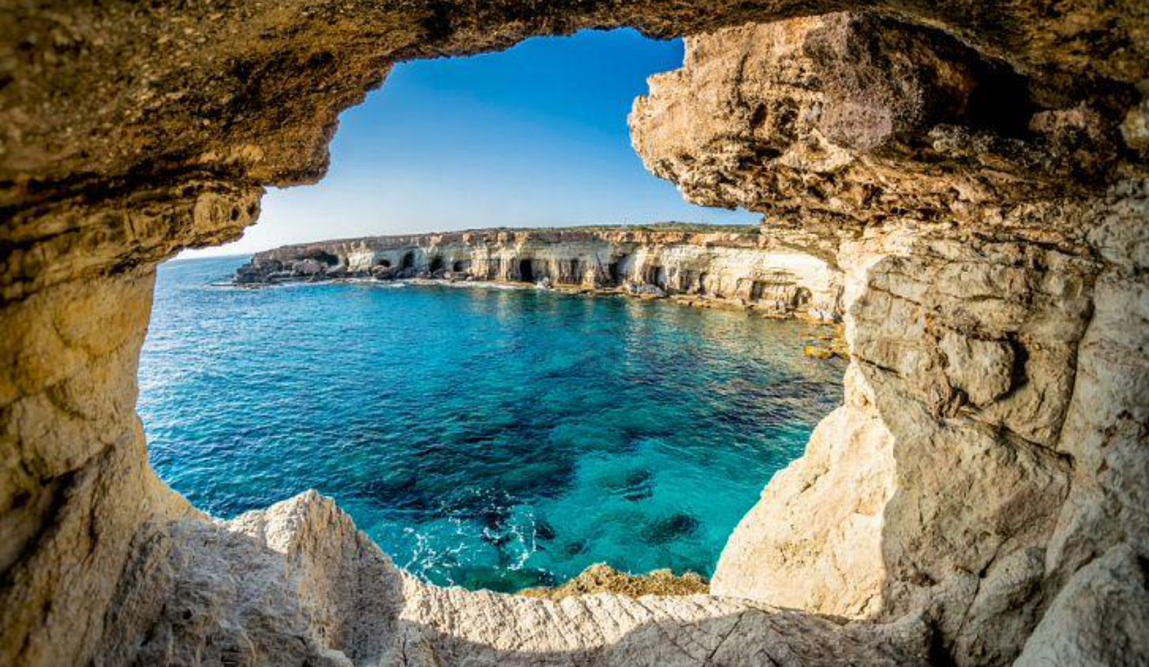
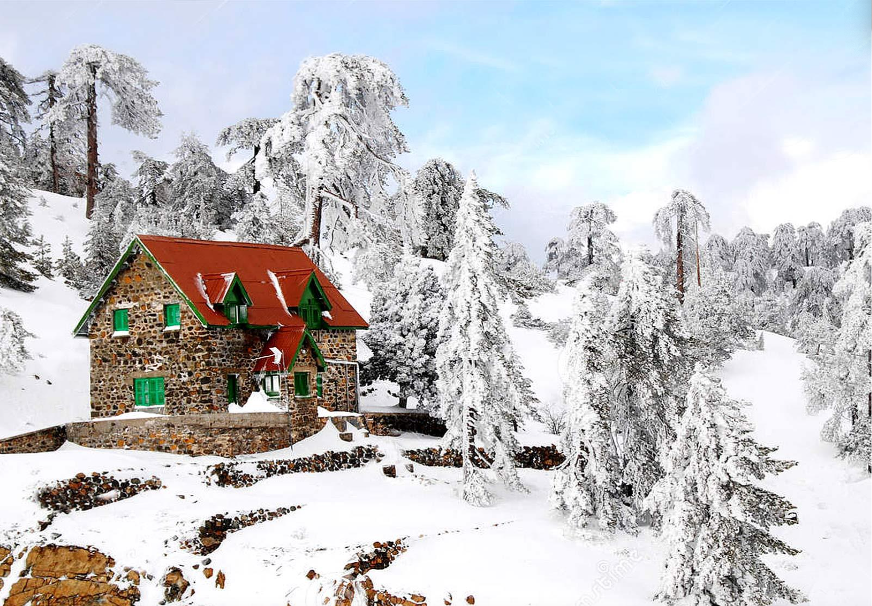

We are looking forward
to meeting
YOU!
YEU – Youth for Exchange and Understanding Cyprus

