
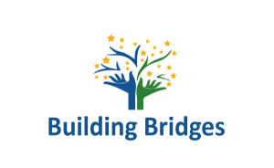 “BESHERPA” SEMINAR
MADRID: 14-18 OF OCTOBER 2018

Organization:
Building Bridges Association (Spain)

Duration:
Arrival date 14th of October (after 15.00) – Departure date 18th of October (after 14.00)
Activity: 14-18 of October

PROJECT DESCRIPTION

BeSherpa is a project promoted by the Building Bridges Association in collaboration with the partners involved, which provides for a training activity of 5 days to be held in Madrid from October 14 to 18, 2018 in which a total of 28 youth workers and tutors of young people will participate. We are in a year in which there will be many changes in relation to European Volunteering with the launch of the new European Solidarity Corps and the disappearance of the name "European Voluntary Service". The organizations active in the Erasmus + program are eager to know all the news and know how to act in the future in the face of these changes. Civil society also expects news because at this time the information is a bit confusing and does not arrive in the best possible way. Organizations that deal with volunteer projects within the Erasmus + program and the European Solidarity Corps will have the opportunity to share their previous experience while learning additional skills and competences that will give them more operational capacity and provide more quality to their future projects. The main need identified is to develop the capacities of accredited coordinating organizations with experience and to improve the quality of coordination in volunteer projects.

The main objectives are:
- guarantee a deep understanding of the project cycle in Volunteer projects;
- explore the role of the coordinating organization in the Volunteer projects;
- update information on recent developments in the field of Volunteer projects and European Solidarity Corps projects;
- be inspired for new forms of association at the local level;
- strengthen the strategic focus of Volunteer projects throughout the project cycle;
- provide a space to share realities, experiences and examples of good practices;
- provide a space for the creation of networks between the participating organizations and the planning of a greater cooperation.

By completing this seminar, participants will be able to:
- define and explain the roles of the coordinating organization for others in volunteer projects;
- understand the challenges faced by the coordinating organizations;
- define and explain the European Solidarity Corps and understand its role;
- establish a map of the minimum quality standards in volunteer projects, based on different contexts and within the cycle of volunteer projects (regions, type of project, volunteer profile, etc.);
- conceptualize the deeper meaning of Volunteer projects and their benefit to the local community, volunteers and organizations;
- improve the quality of Volunteering projects, especially by paying attention to the selection of partners and the selection of volunteers;
- Survey the support mechanisms that an organization provides to volunteers and identify weak points in the support structure;
- reflect critically on the customized Volunteer project;
- identify potential partners for future projects.

The basic elements of the seminar will be:
- INITIAL ANALYSIS: From the European Voluntary Service to the European Solidarity Corps
- EUROPEAN SOLIDARITY CITY: news and objectives.
-INCLUSION AND VOLUNTEERING: how non-formal education helps to prevent and reduce social exclusion.
-THE VALUE OF THE GUARDIAN

PARTICIPANTS’ PROFILE

- Youth workers who collaborate with people in social exclusion situations.
- Social workers with experience in youth information and networking.
- Young volunteers with local or international experience who want to start a professional career in this field.
- Participants’ age: 18 to 35.
- Being able to communicate in English.
- We expect from each partner to choose one male and one female participant to keep the seminar gender-balanced.

Accommodation:
You will stay in Argüelles Apartments in Calle Vallehermoso 3. Each apartment will be shared by 3-4 participants.

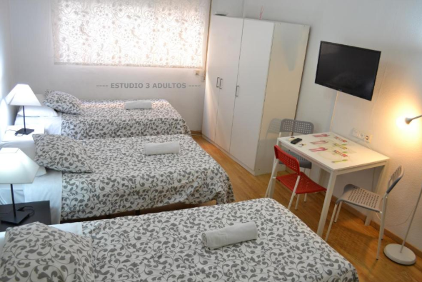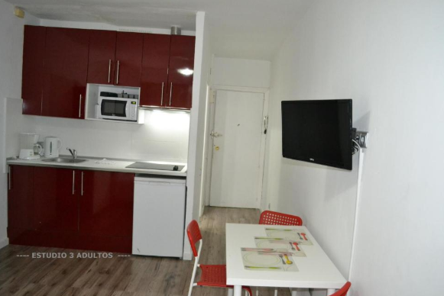

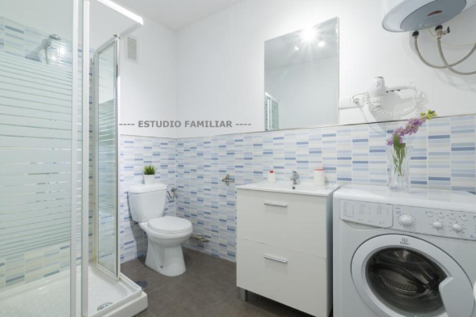
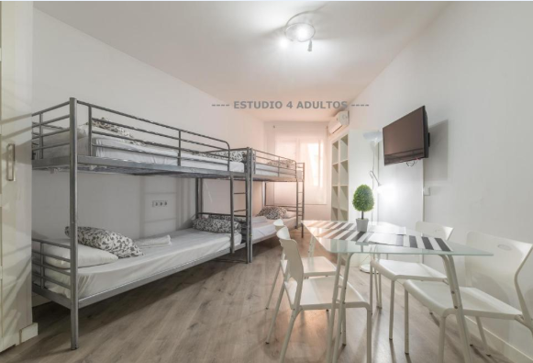

How to arrive?

Both if you arrive at terminal 4 or terminals 1, 2 or 3, take subway line 8 (direction Nuevos Ministerios) and get off in “Mar de cristal”. From there take line 4 (direction Pinar de Chamartín) and get off in San Bernardo (exit named Alberto Aguilera). You will have to walk around 3-4 minutes to the apartments. The cost of the ticket is 1,50€ + 3€ airport supplement and you will need to get a transport card (2€) that can be shared, so if you are coming together with another participant you can buy just one for both.

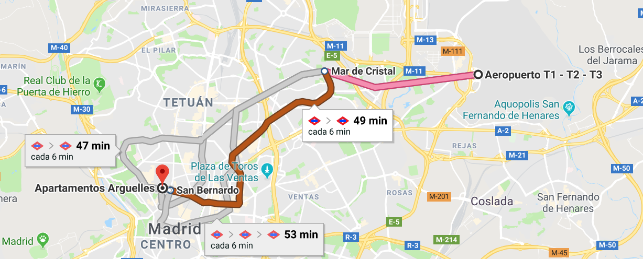
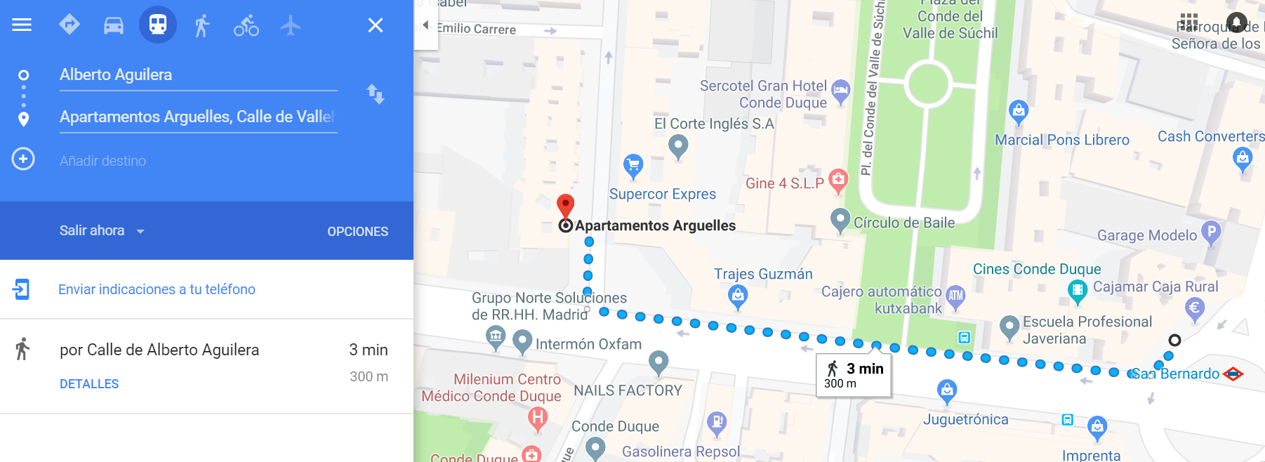

Useful sentences in Spanish

Here you have some words and expressions that can be helpful when you get here:

English | Spanish
Hello | Hola
Good morning / Good evening / Good night | Buenos días / Buenas tardes / Buenas noches
Do you speak English? Yes / No | ¿Hablas inglés? Sí / No
Where is…? Far/Close, Left/Right/Straight | ¿Dónde está…? Lejos/Cerca, Izquierda/Derecha/Recto
My name is… | Me llamo…
Excuse me/Sorry | Disculpa / Perdón…
Thank you | Gracias
Please | Por favor
You’re welcome | De nada
Goodbye | Adiós
I want… water/coffee/tea/beer | Quiero… agua/café/té/cerveza

Weather

The usual temperature in Madrid in October ranges between 10 and 20ºC. It is often a rainy month.

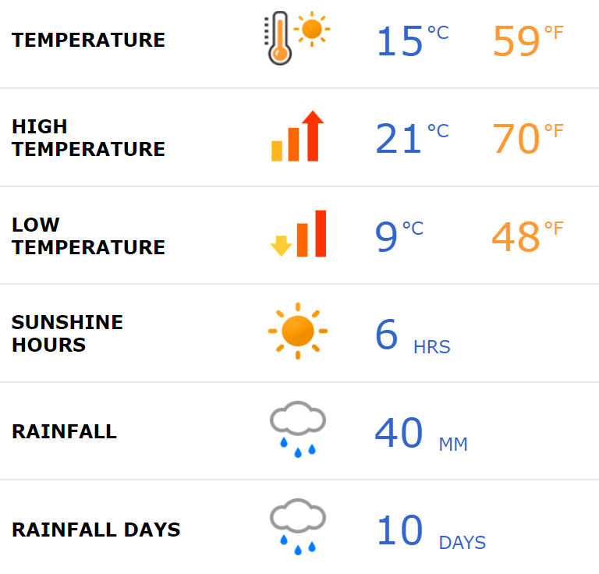

Currency

Local transport: You need to get a transport card before taking the metro/bus. The card costs 2€. A single ticket costs 1,50€, the 10-ticket pass costs 12,20€. You will have to pay a 3€ supplement when getting from the airport to the subway and from the subway into the airport.

One beer or soft drink costs 2-2,50€.

Organizations → 13

- Asociación Building Bridges (Spain)

- Urban Foxes (Belgium)

- Neolea Gia Antalagi Kai Katanoisi (Cyprus)

- Kentro Eidiki Paideia (Greece)

- Associazione Culturale Enjoy Silicy (Italy)

- Psientífica – Associaçao para a promoçao e desenvolvimento social (Portugal)

- Jaunuoliu dienos centras (Lithuania)

- Asociatia Young Iniciative (Romania)

- Fundacja Integracji Spolecznej Prom (Poland)

- Sinop Egitim Programlari Ve Evrensel Ve Kulturel Aktiviteler Dernegi (Turkey)

- Teruletfejlesztok a Videkert Egyesulet (Hungary)

- Mtu Eesti Avatud Noortekeskuste Uhendys (Estonia)

- Schulhaus Europa (Germany)

COST FUNDED

The project seminar costs related to travel, accommodation and activities are covered within the project. For the other expenses (souvenir, extra-food, etc.) each participant should bring money as much as he/she thinks will be needed. Accommodation and lodging covered 100% by the Erasmus+ program.

Please find below the maximum amounts for travel from your country (return ticket):

Lithuania: 360€ per participant (2 participants)
Estonia: 360€ per participant (2 participants)
Germany: 275€ per participant (2 participants)
Portugal: 275€ per participant (2 participants)
Greece: 360€ per participant (2 participants)
Italy: 275€ per participant (2 participants)
Belgium: 275€ per participant (2 participants)
Poland: 275€ per participant (2 participants)
Romania: 360€ per participant (2 participants)
Cyprus: 360€ per participant (2 participants)
Turkey: 360€ per participant (2 participants)
Hungary: 360€ per participant (2 participants)

HOW TO BUY THE TICKETS? AND HOW WILL THEY BE REIMBURSED?

Once you’ve sent the application online and your CV and you’ve been selected, you can proceed with the travel arrangements.

Please buy yourself the tickets, we recommend JetRadar. Before buying the tickets, you need to send us your itinerary and budget for our approval. If you buy your tickets without our approval, you will risk not getting any reimburse for it.
The necessary documents for reimbursement: after all documents have been provided (original tickets boarding passes, etc.) the reimbursement will be done by bank transfer once you get back home.

-The participant can plan his or his stay in Madrid and buy the plane tickets to arrive max. 2 days before the start of the training course and to leave max. 2 days after the end of the training course. The accommodation in those days will be at the expense of the participant.

-Taxi bills will not be reimbursed;

-We need all your receipts, tickets and boarding passes (for both ways). So when you are coming, keep them. After the project you should send us (scanned by email and originals by post) all the tickets boarding passes of the travel back home.

-Insurance will be the participant’s responsibility. If you need a cheap insurance, please contact us. We can provide one for 17€.

ORGANISATION NOTES

Taking into account the educational kind of the project, it is forbidden to use alcohol and other drugs during the project activities;

The project assumes that attendance in all activities for all the participants must be 100%. Failure to attend the activities may result in our inability to reimburse the travel expenses.

The participants are expected to attend the whole duration of the project and participate in all activities.
If an emergency happens and you need to be absent for a short time, the team should be informed in advance. Please use the free time for meeting friends. If you miss any part of the course only without a valid reason (illness or unforeseen grave circumstances) and without informing the team and/or if you cause major problem for the team and your participant group, the team will have to take measures going from partial refunding of the tuition, travel expenses, board and lodging by the participant up to exclusion from the course in extreme situation.

Please note that during the course the team have the authority to take decisions
in a day-to-day life as well as the arrangement of the program.

HOMEWORK

Please prepare an energizer activity to implement during the seminar. We kindly ask participants to be active during the seminar.

Please bring information from your experience as an NGO worker or freelance. You have maximum 3 minutes to present it. Do not forget to bring material about your organization (leaflets, posters, photos, video etc). You can share your project, best practices...

We will create a digital ”Who is who” publication with a picture and basic information from each participant. To create it we will need to know the name of your organization, what type of organization it is, your country of origin, your email address, LinkedIn or Skype contact, the main tasks you carry out and you will also need to finish these sentences “I would like to share…” and “I expect…”.

Please be ready to present your country on the inter-cultural evening in a very informal way, through a short theater play, singing a song, creating a scene that represents something typical… NO Youtube videos or Power Point Presentations!

Each partner will cooperate in the creation of promotional material for being published online.

The partners will be responsible for:
- Promotion and visibility of the project;
- Selection/Nomination of the participant for the project activities; we expect from each partner to choose one male and one female participant to keep the seminar gender-balanced.
- Pre-departure training of the participants;
- Helping to manage the travel arrangements of the participants;
- Attending the seminar;
- Evaluation and reporting;

If you are interested, please send us your application form and your CV to hola@yeseuropa.org
DEADLINE 31/07/2018

WHAT TO BRING?

Please bring your laptop or tablet, we won’t be able to provide you one for the seminar.

DAY | SUNDAY | MONDAY | TUESDAY | WEDNESDAY | THURSDAY
DAY | 14/10/2018 | 15/10/2018 | 16/10/2018 | 17/10/2018 | 18/10/2018
8:30 | ARRIVALS | BREAKFAST
9:30 | ARRIVALS | ENERGYZER | ENERGYZER | To Madrid | ENERGYZER
10.00 | ARRIVALS | PRESENTATION OF TRAINING COURSE PARTICIPANTS & ORGANISATIONS | Creation of common quality standards for the management of volunteering projects | 11-13h: VISIT to some schools in Madrid to interact with young people. Testing methodologies and tools. | Working on creating the pre-departure training manual. Common quality standards.
10.00 | ARRIVALS | Where we are: from EVS to European Solidarity Corps | Creation of a specific mentor profile to work with young people
10.00 | ARRIVALS | Professional project and objectives. | Working in groups
11.00-11.30 | ARRIVALS | COFFEE BREAK |  |  | COFFEE BREAK
11:30 | ARRIVALS | Volunteering and inclusion: How to work with participants with disabilities or in risk of social exclusion | Creation of a validation tool to certify the youth worker's competences. Open Badges. |  | Evaluation. YouthPass and Open Badges Ceremony.
11:30 | ARRIVALS | Work in groups: the mentor's valuable role | Work in groups |  | Evaluation. YouthPass and Open Badges Ceremony.
13:00-15:00 |  | LUNCH | LUNCH | 13:30h: LUNCH-MADRID | LUNCH
15:00-16:30 | 19h: Ice-breakers.  Expectations. | CASE STUDIES: THE HERO'S JOURNEY | CASE STUDY: EMOTIONAL ICEBERG AND CURVE OF ADAPTATION | Work in groups: reflection and debate about the morning work | DEPARTURES
16.30-17.00 |  | COFFEE BREAK |  | Work in groups: reflection and debate about the morning work | DEPARTURES
17:00-18:30 | presentations of each organisation | Work in groups: debate and reflection about the hero's journey | Work in groups: How to solve situations of conflict with the volunteers | FREE TIME IN MADRID | DEPARTURES
17:00-18:30 | Case study: best practices in each country | Presentation of each work | Presentation of each work | FREE TIME IN MADRID | DEPARTURES
17:00-18:30 | (Evaluation) | (Evaluation) | (Evaluation) | FREE TIME IN MADRID | DEPARTURES
20:00 | DINNER | JAM SESSION | DINNER | 21h: DINNER | DEPARTURES

CONTACTS

Info and logistic contacts:

Nino Versace
Tef. +34 692372780

Maria Espinosa
hola@yeseuropa.org

