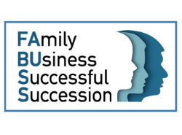
FABUSS TRAINING WORKSHOPS
NICOSIA, CYPRUS
Location: YEU Cyprus, 27, Ezekia Papaioannou, 1075
19 May - 2 June 2018
Agenda
1ST Day 09.00 – 17.00

9.00 – 09.30
Welcome and introduction to FABUSS project (YEU and ENOROS Consulting - Hosts)

09.30 – 10.00
Presentation of FABUSS Training Modules and introduction of the trainer, Christia Flourentzou.

10.00 – 11.30
Module 1: Understanding Family Business Related Issues

11.30 – 12.00
Coffee break

12.00 – 13.30
Module 2: Transnational Similarities and Differences

13.30 – 14.30
Light lunch

14.30 – 16.00
Module 3: Growth Strategies for Family Businesses

16.00 – 17.00
Discussion
2nd Day 09.00 – 17.00
9.00 – 09.30
Welcome to FABUSS training workshop (Part 2)
09.30 – 10.00
Presentation of the rest FABUSS Training Modules and introduction of the trainer, Christiana Yiagkou.

10.00 – 11.30
Module 4: Next Generation Leadership

11.30 – 12.00
Coffee break

12.00 – 13.30
Module 5: Effective Governance & Decision Making

13.30 – 14.30
Light lunch

14.30 – 16.00
Module 6: Communication & Conflict Management

16.00 – 17.00
Discussion

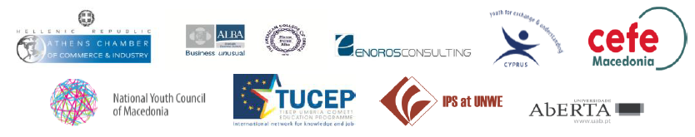
*The FABUSS (FAmily BUsiness Successful Succession) project is a 24 months ERASMUS YOUTH project which aims at helping young persons related to family business become able and effective successors. Its target group consists of 18-35 years old persons who wish to take over their family business at some point in the future. These aspiring successors need skills and knowledge to effectively develop the business by applying new innovative strategies, including extension of their markets, through networking and cooperation with similar enterprises in other countries.

