Step EU Up
Infopack
Mobility of youth workers
11th March- 18th March 2018
Bagnacavallo (Ravenna)

About the project…
The European Union has a history of 60 years when it has overcome challenges, problems and tensions of various kinds. It is also facing great challenges and social, political and economic changes today. These issues have led the Union, as it is increasingly evident in recent times, to be invested by a general wave of Euroscepticism. Various political figures in different European countries are promoting a feeling of mistrust and discouragement towards the European institutions, getting an alarming follow-up between the population.
This project will involve 21 youth workers to deepen the historical knowledge of the European Union and thereby highlight the key moments in which values and strengths emerge, and then find new ways to communicate them effectively.
We look for active and motivated participants in order to develop a new workshop and spread it in the local level!

The venue

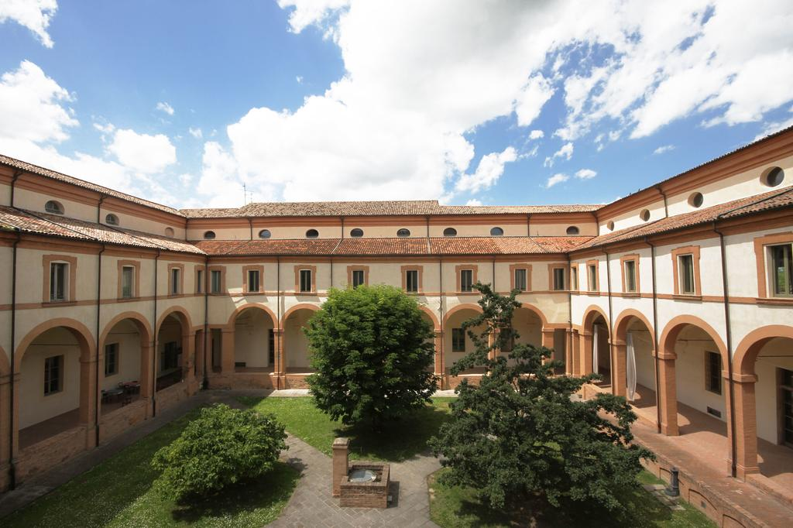
The Training course will be host in "Antico Convento San Francesco", a building property of the Municipality of Bagnacavallo, now managed by a young couple that has turned it into an affordable hotel.
The venue is an historical building in the center of this quiet town and has a lot of large rooms to work in groups, and also a cloister where, if the weather is not too bad, we could have our activities.
The wi-fi connection will be available only during the activities and the intercultural nights, to promote personal relations between the participants.
The bedrooms are for 4-6-8 people and every room has a toilet with a shower
Participant’s profile

Number of participants from each country: 3

Participant’s characteristics:
- At least 21 years old
- Experience in youth work
- Motivation to use the acquired methods in their work
- Good level of English language
- Preferable participants: people active within their organizations
Please check that your health insurance card is still valid before the departure

Please fill in the participant’s form in English and send it to:
projects@yeu-cyprus.org

Costs
The Training course won’t have a participation fee.
The hosting association will sustain accommodation and food. The travel will be reimbursed after attending the total duration of the project and AFTER THE PRESENTATION OF ALL THE TICKETS AND RECEIPS, so please keep all the documents with you. Without ticket and receipts, no reimbursements will be guarantee.
The travel costs will be reimbursed with this maximum:
Country | Max. Reimbursement
Italy | 0
Romania | 275€
Poland | 275€
Cyprus | 360€
France | 275€
Spain | 275€
Macedonia | 275€

Participants MUST attend the whole duration of the youth exchange in order to receive the reimbursement

For more info: projects@yeu-cyprus.org

